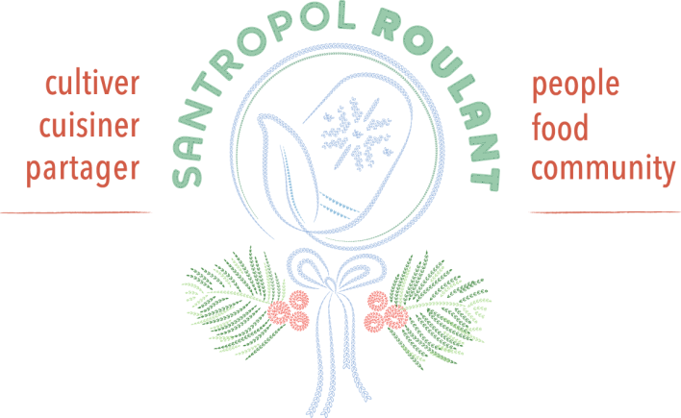

Montreal, December 1st 2017

Dear friend,

As we transition from a year filled with construction to a year rich in new endeavors, we invite you to take a moment to pause with us. One of those moments we relish in the comfort of our home at the end of an invigorating winter day. A moment of reflection before action, as we share our daily work with you in this letter and invite you to consider supporting us financially in order to make it possible for the most isolated Montrealers to access quality food.

Living alone as an elderly person
Until recently, Ms. Vasquez had been able to cook her own meals despite her age. Unfortunately, over the last weeks her fingers have become less nimble, and she has been unable to use kitchen utensils. Her only remaining relative is her niece who lives in Trois-Rivières. Every month Ms. Vasquez pays her $450 rent, which is more than half of her small pension. Once she has paid her bills, she has very little left for food. Until now she would shop in discount grocery stores, yet those are far from her home and with her declining health she cannot go there anymore.

Quality food at an affordable price
Every year Santropol Roulant's Meals-on-Wheels program welcomes dozens of new clients like Ms. Vasquez. They are our next-door neighbours, or the ladies we used to see at the grocery store.
The Roulant team works very hard to keep the prices of our meals reasonable at no more than $5.50 each. In 2017, kitchen co-manager Karine optimized the year-round use of our own farm-grown vegetables in the Meals-on-Wheels. We can now use tomato sauce crafted with tomatoes from Senneville in our lasagna all winter-long!
As you know, we believe that nourishment comes in many forms, so we place great emphasis on connecting with our clients. This year, we reached a major milestone that will make the various services provided by the Roulant physically accessible to them.

An elevator that allows us all to participate in the Roulant's activities
It has taken us seven years to make our accessibility dreams come true. In 2018, thanks to the construction of an elevator, all community members will be able to access the second floor and rooftop of our building to attend gardening workshops, movie nights, and many other events organized in our community space. We are thus reaching the goal we set for ourselves in 2010 when we first moved into the building on Roy Street.

My 92-year-old mother is in better health and has regained her appetite since we started ordering meals from Santropol Roulant!
- Claude A.

Your contribution to improved accessibility
Building the elevator, like the other extraordinary improvements that we have made, reminds us that improving physical, food and financial accessibility requires significant investments. Feeding our community at an affordable price is only possible thanks to the ongoing financial support of our dedicated community of donors. It is for this reason that I write to you today asking that you renew your commitment. Your gift will continue to enable Montrealers to enjoy high-quality, nutritious food that they would not be able to access otherwise. Your donation will have an enormous impact, especially at a time of year when food is celebrated in so many homes.

My sincerest thanks for your generosity. Have a happy holiday season!

Pier
Executive Director

P.S. To receive a tax receipt that can be included in your 2017 tax return, we ask that you please make your donation before December 31st.

